CHAPTER 1
INTRODUCTION

Building construction is a core branch of engineering dedicated to creating safe, functional, and durable structures. While having a secure shelter remains a fundamental human need, the modern reality of constructing a house presents major financial and technical barriers. Today, escalating material costs and high labor charges make independent homebuilding incredibly expensive. As a result, constructing a safe home is often entirely out of reach for the common man, whereas wealthier individuals can easily afford large, luxurious houses.
To address this critical economic gap, the Government of Telangana introduced the 'Indiramma Illu' housing scheme. This initiative is specifically designed to provide safe and affordable housing for the poor. It delivers vital financial assistance directly to families who already own a plot of land but lack the funds required to actually construct a house.
Based on this government initiative, the focus of this project is the "Planning, Analysis and designing of Indiramma illu by manual process". The primary objective is to engineer a highly efficient, single-story (G+0) residential building that maximizes space while strictly adhering to the scheme's economic constraints.
What defines this project is its engineering methodology: the entire structural design is executed completely manually. Instead of relying on automated structural software, every phase—from architectural planning and load calculations to structural analysis and the final design of concrete elements—is calculated strictly by hand. This rigorous manual approach demonstrates a deep understanding of structural behavior and ensures that the final building is safe, durable, and fully compliant with Indian Standard codes.
1.1 CLASSIFICATION OF BUILDINGS:
According to National Building Code of India, 1983, all buildings whether existing or to be constructed are classified based on the character of occupancy in one of the following groups,
GROUP-A : Residential Buildings
GROUP-B : Educational Buildings
GROUP-C : Institutional Buildings
GROUP-D : Assembly Buildings
GROUP-E : Business Buildings
GROUP-F : Mercantile Buildings
GROUP-G : Industrial Buildings
GROUP-H : Storage Buildings
GROUP-I : Hazardous Buildings
In this project the government new house scheme “Indiramma illu” is for Residential building, the definition and the examples of buildings in Group-A residential building are given below.
GROUP-A: Residential Buildings:
These include any building in which sleeping accommodation is provided for normal residential purposes with or without cooking or dining or both facilities.
Buildings and structures under group –A are further subdivided as below:
Subdivision A-1: Loading or rooming houses:
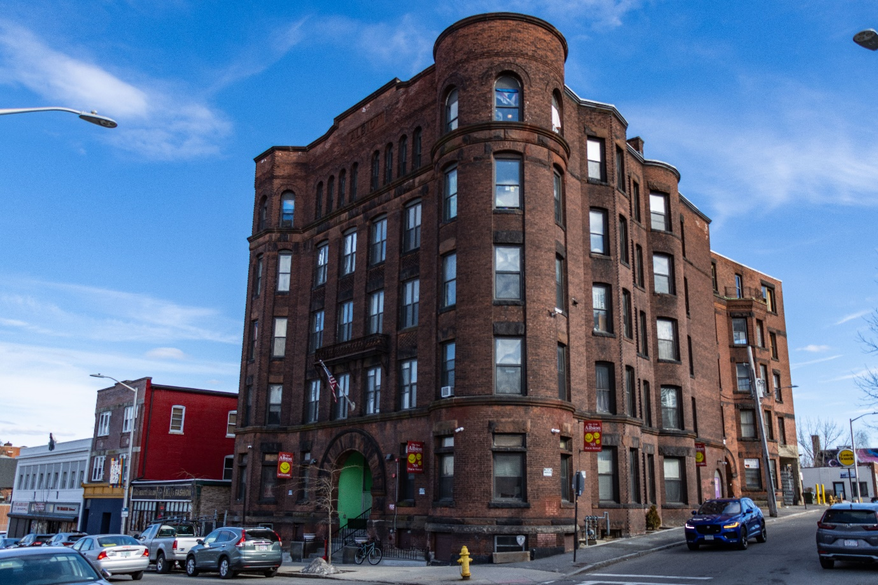
Figure 1.1: Lodging or Rooming House.
These include any building or group of buildings under the same management. These are provided with a separate sleeping accommodation for a total of not more than 15 persons either on temporary or permanent basis. These may be with or without dining facilities, but no facilities for cooking.

Subdivision A-2: One- or two-family private dwelling:
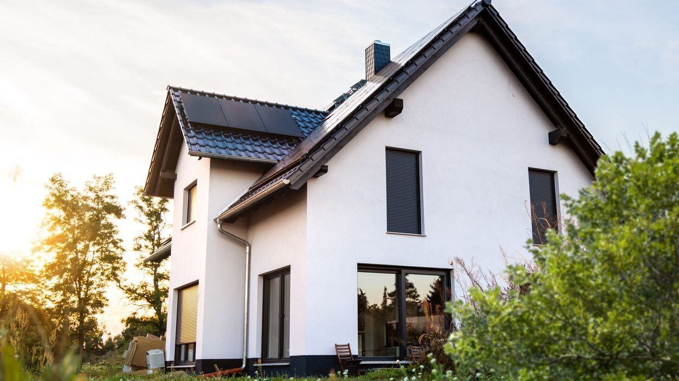
Figure 1.2: Single family private dwelling.
These include any private dwelling which is occupied by members of a single family having sleeping accommodation for not more than 20 persons.
Subdivision A-3: Dormitories:
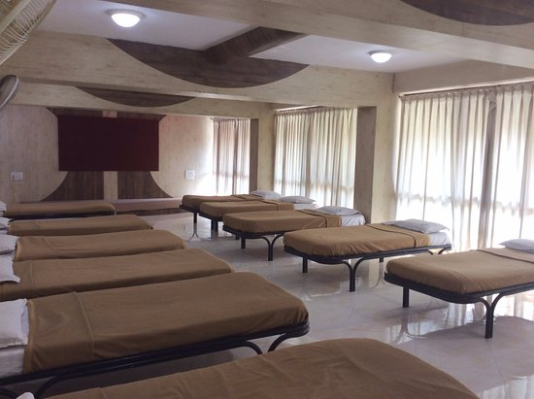
Figure 1.3: Dormitories.
These include any building in which group sleeping accommodation is provided with or without dining facilities .In the persons will not be the members of same family.
EX : School and college dormitories, student’s and other hostels and military barracks.
Subdivision A-4: Apartment houses (Flats) :
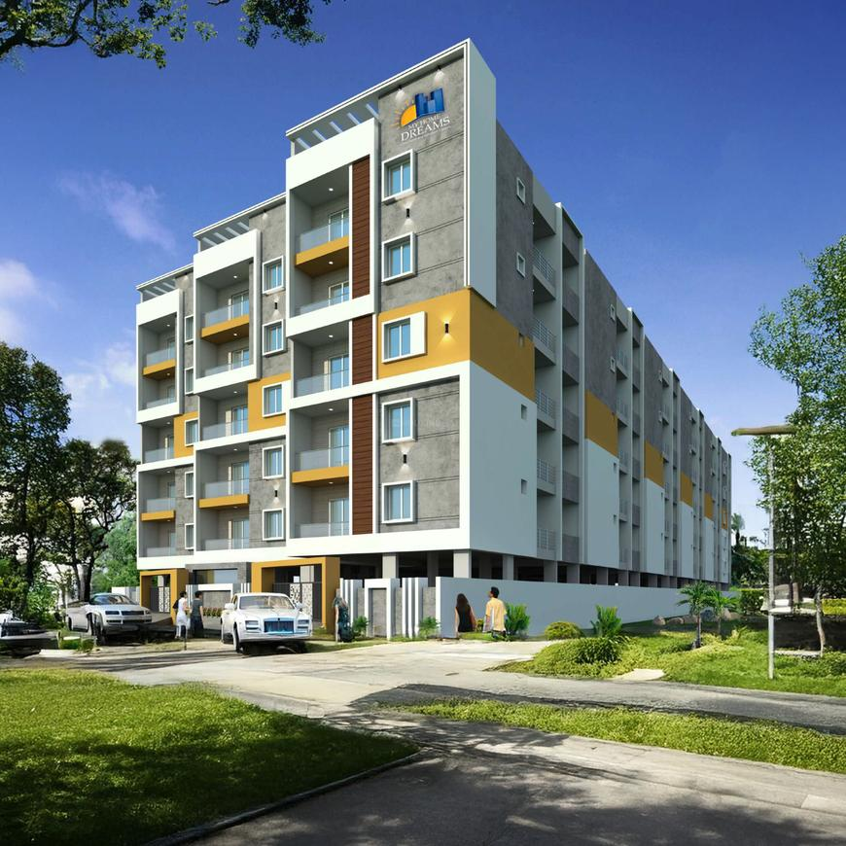
Figure 1.4: Apartment houses.
These include any building or structure in which living quarters are provided for three or more families. They live independently of each other with independent cooking facilities.
EX: Apartment houses, mansions.
Subdivision A-5: Hotels:

Figure 1.5: Hotels.
These include any building or group of buildings under the single management. In this sleeping accommodation with or without dining facilities is provided for hire to more than 15 persons who are purely temporary.
EX: Hotels, Inns, Clubs & motels.
1.2 METHODOLOGY:
Methodology of the project is as follows:

Figure 1.6: Flow chart.

1.3 PROJECT DETAILS:
In this project, we didn’t just want to use Random Dimensions for Plot, So the first thing we did was visit a real site of beneficiary who got Shortlisted in this Scheme. Instead of guessing standard dimensions, we surveyed an actual plot of land handed out under the Indiramma Illu scheme. Getting our boots on the ground meant we could design a house that is actually ready to be built in the real world. We got a plinth area of 54.82m² (590sq. ft).
The Government order says beneficiaries to strictly follow the approved plan of two rooms, kitchen and toilet, with plinth area between 400 to 600 sq. ft. Our plinth area is 590sq. ft. So our plot is under the guideline and Eligible for this Scheme.
During the site visit, we gathered these exact real-world details:
- The Beneficiary: The plot belongs to Smt. B. Kanakamma. Understanding her family's daily needs helped us create a room layout that is actually practical for them to live in.
- The Location: The site is located in Mannapur Village, Kothapalle Mandal, in the Narayanpet District.
- Plot Size & Facing: We measured the site boundaries and recorded a total plot size of 8.05m x 6.81m. The plot faces North, which is a huge detail—it told us exactly where to place the main entrance and how to arrange the windows to get the best natural light and airflow.
- House Dimensions: After leaving the required empty space around the edges of the plot, we locked in a final building area (plinth area) of 590 sq. ft. The actual floor plan of the house is designed at 5.9m x 6.68m.
Using this real site data and keeping the government's strict budget in mind, we set our final structural rules. The building is designed as a simple single-story (G+0) house with a 3.0m ceiling height. For all of our manual calculations, we are using M20 grade concrete and Fe-500 grade steel.
For the economical and safety purpose a proper design is needed, we have done the planning with reference to “National Building code 2016” for interior and exterior plans. these plans are molded in AutoCAD software for drawings. The structural analysis is done manually whereas the designing of various structural components (such as slab, beams, columns, footing etc.) is carried out using “Bureau of Indian Standard Code books” (Given in reference) according to ‘limit state method’. The site plan and plot size are shown in figure 1.7 & 1.8.

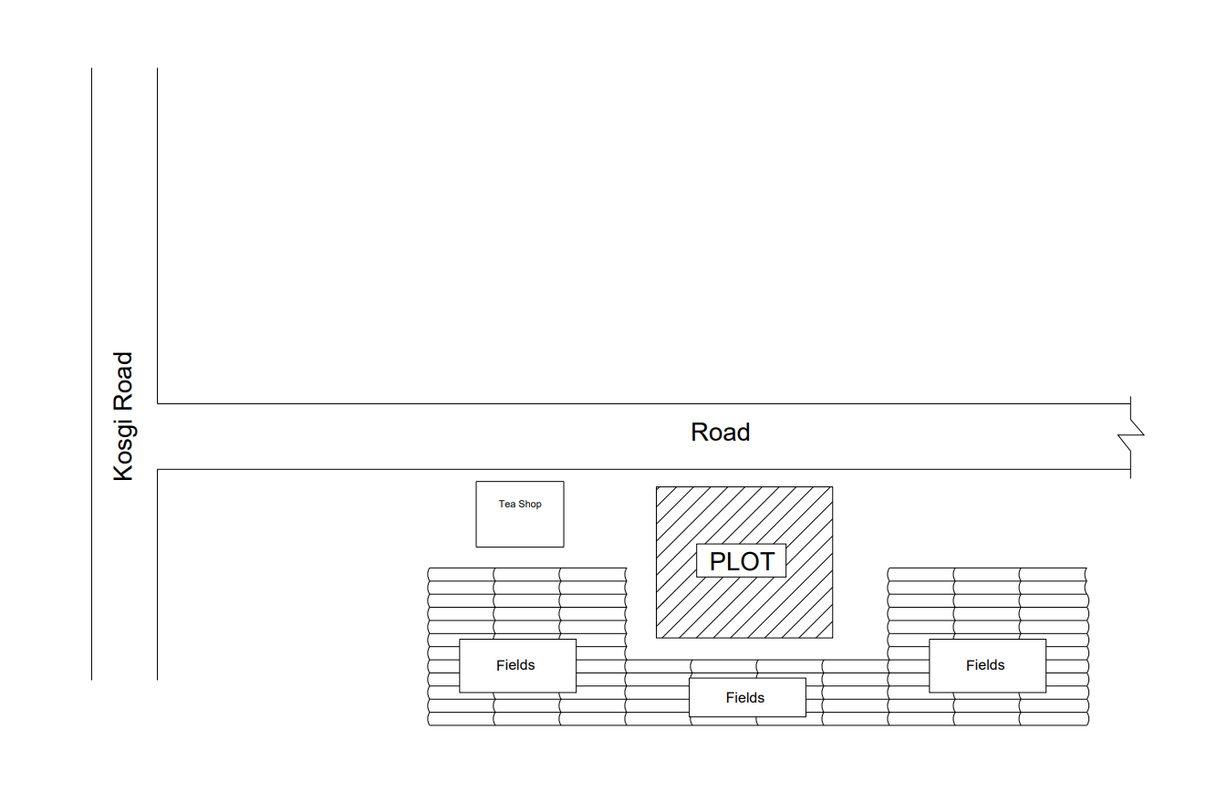Figure 1.7: Site plan.

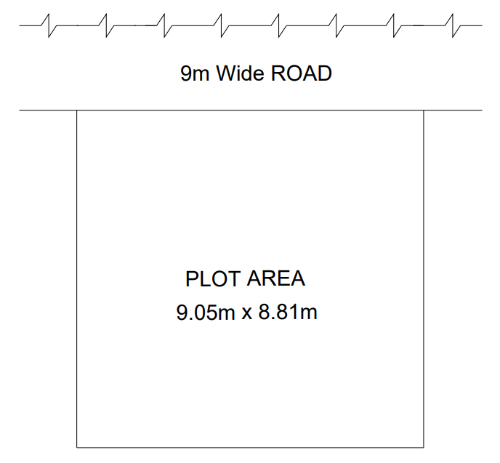
Figure 1.8: Plot size.

